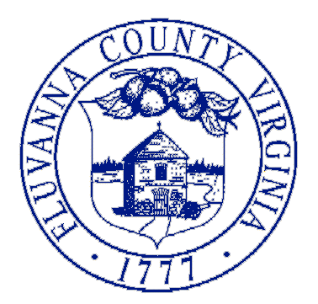
132 Main Street
P.O. Box 540
Palmyra, VA 22963
(434) 591-1910
Fax (434) 591-1911
www.fluvannacounty.org
“Responsive & Responsible Government”

County of Fluvanna

April 12, 2022

To: All Permit Holders, Contractors

From: County of Fluvanna Building Inspections
Andrew W. Wills Building Official

Starting today April 12, 2022 prior to any inspections being scheduled or third party inspections accepted ALL TRADE PERMITS THAT ARE REQUIRED FOR YOUR JOB MUST BE ISSUED.
There has been lots of confusion and headaches due to contractors not getting there permits in a timely manner and requests for inspections where no permits have been issue. We feel this is the only way to solve this problem.

Thank You

