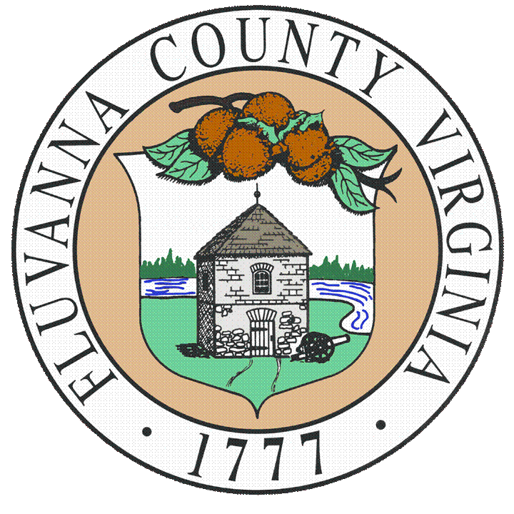
Fluvanna County, Virginia
Department of Clerk of the Circuit Court
Job Description

DEPUTY CLERK IV - PROBATE CLERK
Job Class #: | 1841
Pay Grade: | 16
Category: | Full-Time(with benefits)
FLSA Status: | Non-Exempt (Hourly)
Reports To: | Clerk of Court
SUMMARY
Represents Fluvanna County in the day-to-day operations of the Circuit Court Clerk’s Office. Performs a variety of tasks involving complex matters of Wills, Trusts, and Fiduciaries. This position performs the function of quasi-judge for probate matters as assigned to the Clerk of Court by the Code of Virginia. Provides instruction and supervision on all matters related to probate. Works under the supervision of the Circuit Court Clerk, however, does supervise other employees.
ESSENTIAL FUNCTIONS
- Maintain extensive knowledge of probate, guardian conservatorship, and trust laws in Virginia and legislative updates to such laws. This includes the entirety of Title 64.2 of the Code of Virginia and includes but is not limited to Sections included in Title 17.1 (Courts of Record), 58.1 (Taxation), 8.01 (Civil Remedies and Procedures) of the Code of Virginia.
- Understand complex matters relating to probate, administration of estates, administration for other purposes, testamentary guardians, guardianships, conservatorships, guardians for a minor, etc.
- Determine jurisdiction and whether the action can be filed and/or probated in Fluvanna County in accordance with the law.
- Review all Wills, foreign or domestic, to determine if the will and/or codicil are valid and meet all criteria to be probated under Virginia law.
- Determine and require strict compliance with legal requirements for proving a Will in Virginia. (Attested Wills, Self-Proving Wills, Holographic Wills, Nuncupative, Joint Wills, Foreign Wills)
- Rejection of Wills that do not adhere to legal requirements.
- Preparation of rejection orders.
- Effectively communicate with the public relating to probate and estate matters.
- Collection of necessary and required information and forms for preparation of probate documents.
- Must have a working knowledge of Descent and Distribution in Virginia, including but not limited to afterborn heirs, inheritance rights, collaterals of the half-blood, etc.
- Determine whether probate or grant of administration is necessary and communicate the considerations to heirs or proponent of Will regarding what may be necessary or required.
- Prepare and explain Real Estate Affidavits.
- Prepare and/or explain the Small Estate Affidavit and requirements.
- Compel the production of a Will, if necessary.
- Understand and have the ability to explain the Uniform Simultaneous Death Act, if necessary.
- Working knowledge of the Uniform Adult Guardianship and Protective Proceedings Jurisdiction Act, Uniform Fiduciary Access to Digital Assets Act, Virginia Small Estate Act, and other acts included in Title 64.2 of the Code of Virginia.
- Qualify personal representatives (i.e. executors, administrators, administrators cta, curators, testamentary trustees, guardians, conservators, guardians of minors or their estates, committee, etc.)
- Prepare and explain Affidavits of Notice and know the laws relating to such.
- Determine the suitability, fitness, and competence of a person requesting qualification.
- Knowledge of Acts barring property rights commonly known as the “Slayer Statutes”.
- Prepare the Probate Tax Return and have a working knowledge of related tax statutes in Virginia.
- Calculate and collect all probate taxes and fees.
- Determine the bond for the estate, including the penalty of the bond, security on the bond, when security shall be waived, and when security may be waived.
- Explain and provide a statement of responsibilities to an executor or administrator at the time of probate.
- Prepare certificates of qualification, letters of testamentary, and/or letters of administration.
- Ensure that a resident agent is appointed, if necessary, and explain the law regarding such.
- Index and scan all required documents to the Will Book and distribute copies as required.
- Determine retention schedules based on Library of Virginia standards and assist with destruction when necessary.
- Train staff to assist with preliminary probate matters and supervise staff.
- Prepare and furnish, in accordance with the law, required lists, reports, and revocations to the Commissioner of Accounts.
- Publish notices to show cause against distribution.
- Issue summons against fiduciaries as reported and requested by the Commissioner of Accounts.
- Maintain a working relationship with the Commissioner of Accounts and assistants.
- Review all inventories upon filing by the Commissioner of Accounts and compare them to Probate Tax Returns. If additional probate tax is required, communicate with the fiduciary, prepare the amended probate tax return, and collect additional probate tax.
- Record, index, and scan all Settlements, Statements in Lieu of Accountings, Accounts of Trustees Sales, and Exemption claims.
- Working knowledge of exemption claims, disclaimers, insolvent estates, elective shares, and augmented estate and ability to explain such claims and allowances.
- Prepare and explain documents related to the appointment and qualification of guardians and conservators in compliance with the order of the court.
- Understanding of county ordinances as they relate to probate tax, plats, and other matters relating to this office.
- Working knowledge of Titles 17.1, 55.1, and 58.1 of the Code of Virginia relating recordation of land records, including but not limited to, taxation, recording standards, indexing, notarial acts, and Uniform Real Property Electronic Recording Act.
- Perform end-of-day reconciliation of monies and prepare necessary financial records.
- Handle telephone calls and route or independently assist the public with information and requests.
- Handle walk-in citizens and assist with requests, research, and information.
- Recordation of e-recordings, land records, and plats.
- Issue marriage licenses, process concealed handgun permits, accept and process passports and Notary Public oaths, and perform land records research.
- Provide exemplary customer service to all patrons of the office.
- Perform all other related or assigned tasks.

REQUIRED KNOWLEDGE, SKILLS, AND ABILITIES
Knowledge of:
- Relevant federal and state laws, county ordinances, and clerk’s office policies and procedures.
- Various Acts set out in the Code of Virginia relating to the position.
- Modern office practices, procedures, and equipment.
- Public communication techniques and strategies.
- Land recordation requirements and laws.
Skills in:
- Supervision and interpersonal relations.
- Problem solving.
- Human relations and communications including the ability to instruct and supervise.
- Prioritizing and planning.
- Collect, evaluate, and interpret complex information and data.
- Preparing, presenting, and explaining documents, laws, and procedures.
- Oral and written communications.
- Preparing and presenting information and public speaking.
- Operation and use of common office equipment including personal computers and copiers, and job-related software programs.
- Establishing and maintaining professional and effective working relationships with the public, public officials and employees, public agencies, and external partners.
Ability to:
- Pay attention to detail and maintain accuracy.
- Thrive in a fast-paced, high-stress environment.
- Read cursive and assist the public with reading historic records.
- Independently carry out assignments, set priorities, meet critical deadlines, and follow up on assignments with minimal direction.
- Establish and maintain professional and effective working relationships with the Office of the Executive Secretary, Commissioner of Accounts and staff, local agencies and offices, and community members.
- Prepare and present clear and effective documents, correspondence, and other materials.
- Analyze complex issues and develop specific solutions.
- Instruct and supervise other office employees in necessary tasks related to this position.
- Interpret, apply, and explain complex laws, codes, regulations, policies, and procedures.
- Demonstrate leadership within the clerk’s office.
ACCEPTABLE EDUCATION, EXPERIENCE, AND TRAINING
- Any combination of education and/or experience equivalent to graduation from an accredited college or university with a degree in paralegal studies, court administration, public relations, or a closely related field or three (3) to five (5) years of experience in probate and estates or legal work, that includes professional-level understanding and interpretation of laws.
- Advanced proficiency in Microsoft Office.
- Willingness to enroll and attend courses relative to the operations of a Circuit Court Clerk’s office, obtain certifications necessary to perform job tasks, and participate in continuing legal education.
WORKING CONDITIONS AND PHYSICAL REQUIREMENTS
- Must have the ability to occasionally lift, push/pull, and hold/carry 25 pounds.
- Must have the ability to frequently stand and sit, and occasionally walk over flat and uneven terrain.
- Local travel is required for bank business, meetings, and/or presentations.
- Some travel for training and education.
- Vocal communication is required for expressing or exchanging ideas using the spoken word.
- Hearing is required to perceive information at normal spoken word levels.
- Visual acuity is required for preparing and analyzing written or computer data, determining the accuracy and thoroughness of work, and observing general surroundings and activities.
POST OFFER REQUIREMENTS
- Criminal Background Check
Department Head  Recommended: | Director of HR  Approval as to Form: | County Administrator  Recommended: | Board of Supervisors  Approved:
April 10, 2024 | April 10, 2024 | April 10, 2024 | June 20, 2024

