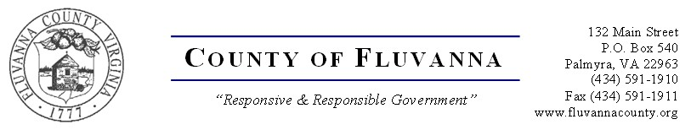

IFB 2023-01 Attachment E | INVITATION TO BID:  BURN BUILDING CONSTRUCTION | BID OPENING:  September 29, 2022, AT  2:00 p.m.
NOTICE TO ALL BIDDERS: All equipment and/or services provided under this invitation for Bid shall conform to the specifications and all terms and conditions as set forth.

Have all Specifications included in this Invitation for Bid been met? [ ] Yes [ ] No

If no, please list all exceptions in detail on separate sheet.

Person to contact regarding this bid:

Title: Phone:

Email Address:

Name of person authorized to bind the Firm:

Signature: Date:

Name of Company:

Address:

By signing this bid, bidder certifies, acknowledges, understands and agrees to be bound by the conditions set forth in the contents of the bid including the General Terms and Conditions.
Work Description | Price
LUMP SUM COST FOR SITE DEVELOPMENT AND INFRASTRUCTURE
LUMP SUM COST FOR BURN BUILDING CONSTRUCTION AND PERIMETER CONCRETE APRON
TOTAL CONSTRUCTION COST
Optional Pricing (not required for this bid award)
Work Description | Price

